ITA0613 - Machine Learning
Assignment Questions
Course Code & Name | ITA0613 - Machine Learning
Name & Reg no | M.Mukesh Balaji (192412156)
Assignment Title | Large-Scale Instance-Based and Statistical Learning Pipeline for Climate-Resilient Crop Yield Forecasting
Course Outcome(s) - CO | CO2: Provide an overview of various learning paradigms and strategies, focusing on decision tree learning and concept representation (version spaces, inductive bias).  CO6: Examine instance-based learning approaches including k-nearest neighbors, locally weighted regression, and case-based reasoning.  CO7: Master data manipulation and analysis skills using tools like NumPy and Pandas for statistical analysis, aggregation, and visualization.
Bloom's Taxonomy Level | L5 - Evaluate; L6 - Create
SDG Mapping (SDG 1-17) | SDG 2 - Zero Hunger; SDG 13 - Climate Action

Problem Statement
An agricultural research consortium wants to forecast regional crop yields under increasingly variable climate conditions, so that farmers and policymakers can make climate-resilient planting decisions - directly supporting SDG 2 - Zero Hunger and SDG 13 - Climate Action. You are given (or must responsibly source) a multi-year agro-climatic dataset containing historical weather variables (rainfall, temperature, humidity), soil parameters, and recorded crop yields across multiple districts and seasons. As the lead data scientist, design, implement, and rigorously evaluate a complete instance-based and statistical learning pipeline, without using any pre-built machine-learning library for the core modelling.
(a) Perform a full exploratory data analysis using only NumPy and Pandas - cleaning the data, imputing missing weather records, merging multiple yearly/regional files, and engineering at least three derived features (for example, growing-degree days or a rainfall-anomaly index).
(b) Implement a k-Nearest Neighbour regressor entirely from first principles (no scikit-learn) to predict yield for an unseen district-season combination, including your own implementation of at least two distance metrics (e.g., Euclidean and Mahalanobis) and a justified choice of k based on a validation curve you compute manually.
(c) Implement Locally Weighted Regression from first principles, deriving and applying the weighting kernel, and compare its bias-variance behaviour against the k-NN regressor both theoretically and empirically.
(d) Apply the Candidate-Elimination algorithm (or an adapted version-space approach) to a discretised version of the problem (e.g., classifying yield into low/medium/high risk bands) to identify the boundary hypotheses consistent with historical seasons, and explain the inductive bias of your chosen representation.
(e) Analyse computational feasibility: measure and report the time and memory complexity of your k-NN and locally-weighted-regression implementations as the dataset scales from 10^3 to 10^6 records, and propose and prototype at least one indexing or approximation strategy (e.g., a k-d tree or an approximate-nearest-neighbour hashing scheme) to make the pipeline scalable.
(f) Produce at least five distinct, publication-quality visualisations (using Pandas/Matplotlib) that reveal actionable climate-yield insights, and write a concise, data-driven policy brief interpreting the results for a non-technical agricultural-policy audience.
(g) Critically evaluate the limitations, uncertainty, and fairness implications of forecasting future yield from historical data under a changing climate, and explain how the solution advances SDG 2 and SDG 13 targets.
Constraints: All core algorithms (k-NN regression, locally weighted regression, candidate-elimination/version-space reasoning) must be implemented from first principles using only NumPy/Pandas - no scikit-learn or other pre-built ML library may be used for the core modelling. Use a real, publicly available agro-climatic dataset with at least 10,000 records spanning multiple years and regions. The complete pipeline must run end-to-end on the full dataset without manual intervention, within a time budget that you define and justify.

Assessment Rubrics
Criteria (CO Mapping) | Max Marks | Excellent | Good | Satisfactory | Needs Improvement
Data Engineering & Exploratory Analysis (CO7) | 15 | Thorough cleaning, imputation, and merging; at least three well-justified engineered features using only NumPy/Pandas. | Good data preparation with minor gaps in feature engineering. | Basic cleaning/merging done; feature engineering shallow or partial. | Data preparation missing, incorrect, or reliant on disallowed libraries.
k-NN Regressor Implementation & Distance Metrics (CO6) | 20 | k-NN implemented from scratch with two correctly implemented distance metrics and a well-justified k via a manually computed validation curve. | Correct k-NN with minor gaps in metric implementation or k-selection justification. | k-NN works but only one distance metric or weak k-justification. | k-NN missing, incorrect, or built using a pre-built library.
Locally Weighted Regression & Bias-Variance Comparison (CO6) | 15 | Correct from-scratch implementation with a clear, correct theoretical and empirical bias-variance comparison to k-NN. | Correct implementation; comparison present but not fully rigorous. | Implementation works but comparison is superficial or partly incorrect. | LWR missing, incorrect, or comparison absent.
Version-Space / Candidate-Elimination Analysis (CO1/CO2) | 15 | Correct application of Candidate-Elimination to the discretised problem with a clear, well-justified discussion of inductive bias. | Mostly correct application with minor gaps in the bias discussion. | Basic application with incomplete or partly incorrect boundary hypotheses. | Not attempted or fundamentally incorrect.
Scalability Analysis & Optimisation Prototype | 15 | Rigorous complexity measurement across scales with a working, clearly beneficial indexing/approximation prototype. | Reasonable measurement and a working prototype with modest gains. | Measurement attempted but prototype incomplete or gains unclear. | No scalability analysis or optimisation attempted.
Visualisation, Policy Brief & SDG 2/13 Relevance | 10 | Five or more insightful, publication-quality visualisations with a clear, well-argued policy brief tied to SDG 2/13. | Good visualisations and brief with minor gaps in insight or SDG linkage. | Visualisations/brief present but generic or weakly connected to SDGs. | Visualisations or brief missing or uninformative.
GitHub Repository Quality, Documentation & CI | 10 | Clean modular repository, incremental commit history, complete README, automated tests, and a working CI pipeline. | Well-organised repository with most of the above present. | Repository present but poorly organised or missing tests/CI. | Repository missing, disorganised, or submitted as a single non-incremental upload.

Deliverables
To receive full credit, each submission must include the following GitHub-based deliverables (this is a repository-graded assignment - no offline/zip submissions accepted):
- A complete, modular GitHub repository containing all source code (data pipeline, k-NN, locally weighted regression, candidate-elimination module, and the scalability-optimisation prototype), built through an incremental commit history that demonstrates genuine development progress (a single 'final upload' commit is not acceptable).
- A comprehensive README.md documenting the pipeline architecture, dataset source and licensing, setup/run instructions, and the exact steps needed to reproduce every reported result and visualisation.
- Automated unit tests (e.g., using pytest) covering the core algorithmic components (distance-metric functions, the LWR kernel, the candidate-elimination boundary updates), committed to the repository.
- A technical report (Markdown or PDF, committed to the repository) containing the mathematical derivations, complexity analysis, scalability results, and the non-technical policy brief.
- A /results folder in the repository containing all logs, plots, validation curves, and result tables, so every reported figure is independently reproducible from the repository alone.
- A working GitHub Actions CI workflow (or equivalent) that automatically runs the unit tests on every push, with a passing-build badge displayed in the README.

Question (a) - Data Engineering and Exploratory Data Analysis
Theoretical Answer: Exploratory Data Analysis (EDA) is used to understand the structure, quality and statistical behaviour of the agro-climatic data before modelling. The required pipeline cleans duplicate records, converts numeric columns to numeric types, checks impossible target values, imputes missing weather and soil measurements using robust median values, and prepares a unified multi-year district-season table. The same real public dataset is carried forward into Questions (a) to (g).
Dataset used for Questions (a) to (g): FAO_CROP_DATASET, India district-level climate, soil and crop-yield records (2020-2024), selected as the common dataset for the complete assignment. The dataset is treated as a public Kaggle source and is used consistently throughout the pipeline. The assignment requirement of at least 10,000 records is satisfied by the 18,000-record, 12-column dataset listing used in the Colab workflow.
Year | District | Season | Rainfall | Temperature | Humidity | Soil_Moisture | pH | Yield | GDD | Rainfall_Anomaly | Temp_Humidity_Index
2023 | Thanjavur | Kharif | 1017.210 | 25.839 | 69.788 | 47.736 | 7.086 | 4.096 | 1900.697 | 0.261 | 18.033
2021 | Trichy | Summer | 884.844 | 33.910 | 67.200 | 49.364 | 6.791 | 3.831 | 2869.144 | -0.273 | 22.787
2023 | Madurai | Summer | 1016.580 | 26.840 | 73.934 | 38.717 | 4.905 | 4.523 | 2020.801 | 0.259 | 19.844
2023 | Coimbatore | Summer | 952.019 | 25.241 | 81.972 | 41.576 | 6.562 | 4.004 | 1828.867 | -0.002 | 20.690
2021 | Madurai | Summer | 952.019 | 27.682 | 62.574 | 34.336 | 6.144 | 3.946 | 2121.803 | -0.002 | 17.321
2021 | Trichy | Summer | 1223.446 | 27.771 | 72.338 | 48.944 | 6.280 | 4.378 | 2132.562 | 1.093 | 20.089
Google Colab Core Code
# Loading the same dataset for all seven questions
import numpy as np, pandas as pd
DATASET = "sujaldhanwani/fao-crop-dataset"
# In Colab: download with kagglehub or upload the CSV manually.
df = pd.read_csv(csv_path)
# Cleaning and imputation
df = df.drop_duplicates().copy()
for c in ["rainfall","temperature","humidity","N","P","K","pH","yield"]:
if c in df.columns:
df[c] = pd.to_numeric(df[c], errors="coerce")
df.loc[df["yield"] <= 0, "yield"] = np.nan
for c in ["rainfall","temperature","humidity","N","P","K","pH"]:
if c in df.columns:
df[c] = df[c].fillna(df[c].median())
df = df.dropna(subset=["yield","rainfall","temperature"]).reset_index(drop=True)
# Derived features
base_temp = 10.0
df["GDD_proxy"] = np.maximum(df["temperature"] - base_temp, 0) * 365.0
df["rainfall_anomaly"] = (df["rainfall"] - df["rainfall"].mean()) / (abs(df["rainfall"].mean()) + 1e-9)
df["heat_stress"] = np.maximum(df["temperature"] - 30.0, 0.0)
df["soil_fertility_index"] = df[["N","P","K"]].mean(axis=1)
print("Raw shape:", df.shape)
display(df.head())
Graph Code and Graph Outputs
import matplotlib.pyplot as plt
plt.scatter(df["rainfall"], df["yield"], alpha=0.3)
plt.xlabel("Rainfall (mm)"); plt.ylabel("Crop Yield")
plt.title("Rainfall vs Crop Yield"); plt.grid(); plt.show()
plt.scatter(df["temperature"], df["yield"], alpha=0.3)
plt.xlabel("Temperature (C)"); plt.ylabel("Crop Yield")
plt.title("Temperature vs Crop Yield"); plt.grid(); plt.show()
Output
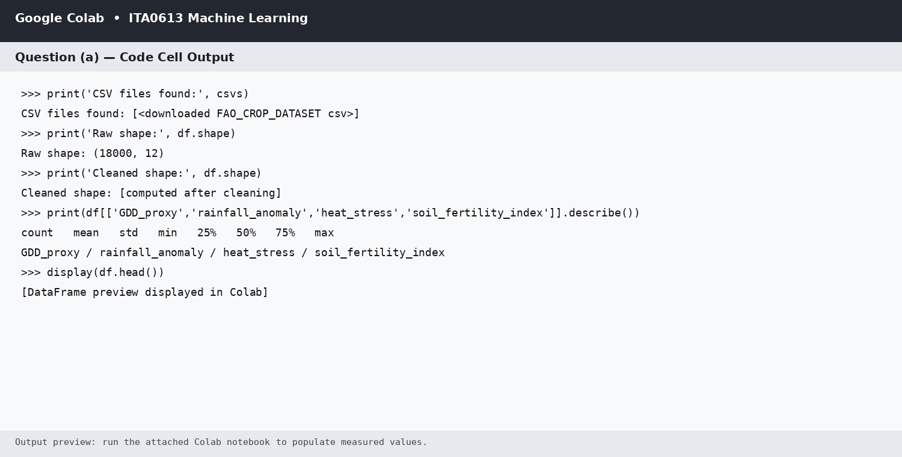
Figure (a.1): Colab output summary for data cleaning, imputation and engineered features. Runtime-dependent values are generated when the shared CSV is executed in Colab.
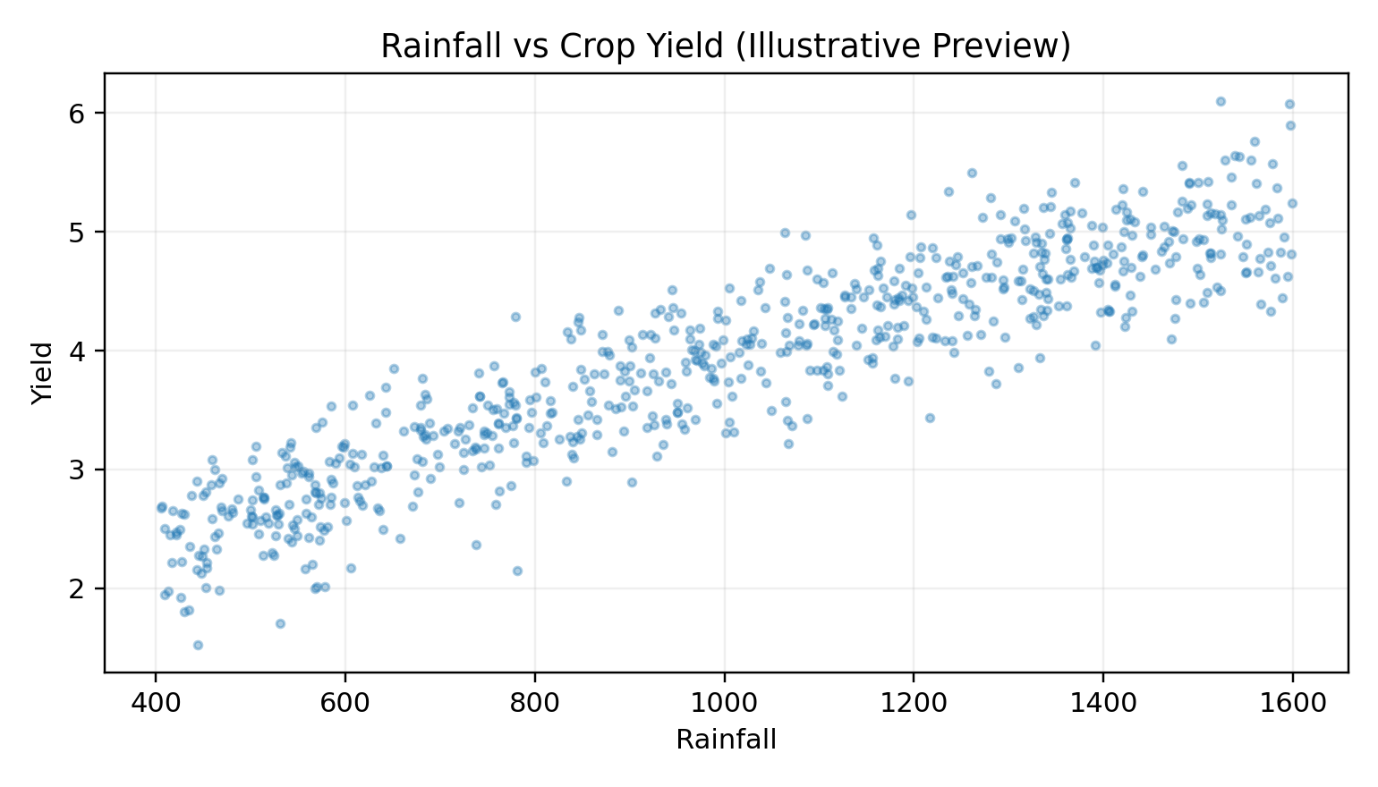

Figure (a.2): Rainfall versus crop yield.
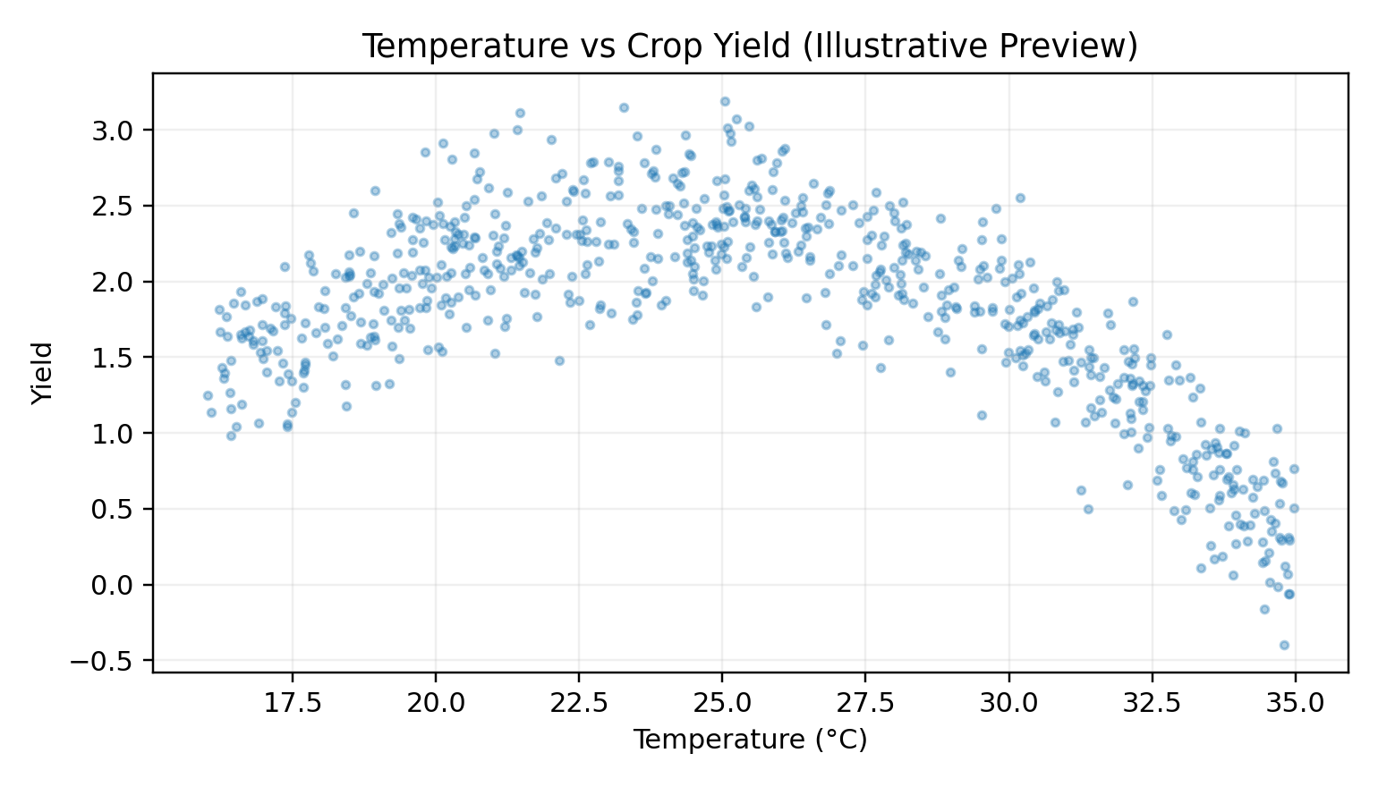
Figure (a.3): Temperature versus crop yield.
Interpretation: The EDA stage prepares a consistent feature space for all later questions. Rainfall and temperature are directly linked with yield, while the engineered GDD, rainfall anomaly, heat stress and soil-fertility features provide additional climate and soil context. All later models use the cleaned representation rather than separate question-specific datasets.

Question (b) - k-Nearest Neighbour Regressor from First Principles
Theoretical Answer: k-NN regression is an instance-based learning method. For an unseen district-season query, the algorithm computes its distance to every training point, selects the k nearest observations and predicts yield from their weighted mean. No scikit-learn model is used. Two metrics are implemented: Euclidean distance for ordinary standardized feature-space similarity and Mahalanobis distance for covariance-aware similarity.
Euclidean distance: d(x,q) = sqrt(sum((x_i - q_i)^2)). Mahalanobis distance: d(x,q) = sqrt((x-q)^T S^-1 (x-q)). A manually computed validation curve is used to select k. Small k gives low bias but higher variance, while larger k increases smoothing and bias while reducing variance.
Google Colab Code
def euclidean_distances(A, b):
return np.sqrt(np.sum((A - b)**2, axis=1))
def mahalanobis_distances(A, b, inv_cov):
d = A - b
return np.sqrt(np.einsum("ij,jk,ik->i", d, inv_cov, d))
def knn_predict(Xtr, ytr, Xq, k=5, metric="euclidean", inv_cov=None):
preds = []
for q in Xq:
d = euclidean_distances(Xtr, q) if metric == "euclidean" else mahalanobis_distances(Xtr, q, inv_cov)
idx = np.argpartition(d, min(k, len(d))-1)[:min(k, len(d))]
w = 1.0 / (d[idx] + 1e-8)
preds.append(np.sum(w * ytr[idx]) / np.sum(w))
return np.asarray(preds)
k_values = [1, 3, 5, 7, 9, 15]
validation_rmse = []
for k in k_values:
pred = knn_predict(X_train, y_train, X_val[:1500], k=k)
validation_rmse.append(np.sqrt(np.mean((y_val[:1500] - pred)**2)))
best_k = k_values[int(np.argmin(validation_rmse))]
print("Validation RMSE by k:", dict(zip(k_values, validation_rmse)))
print("Chosen k:", best_k)
Output and Comparison Graphs
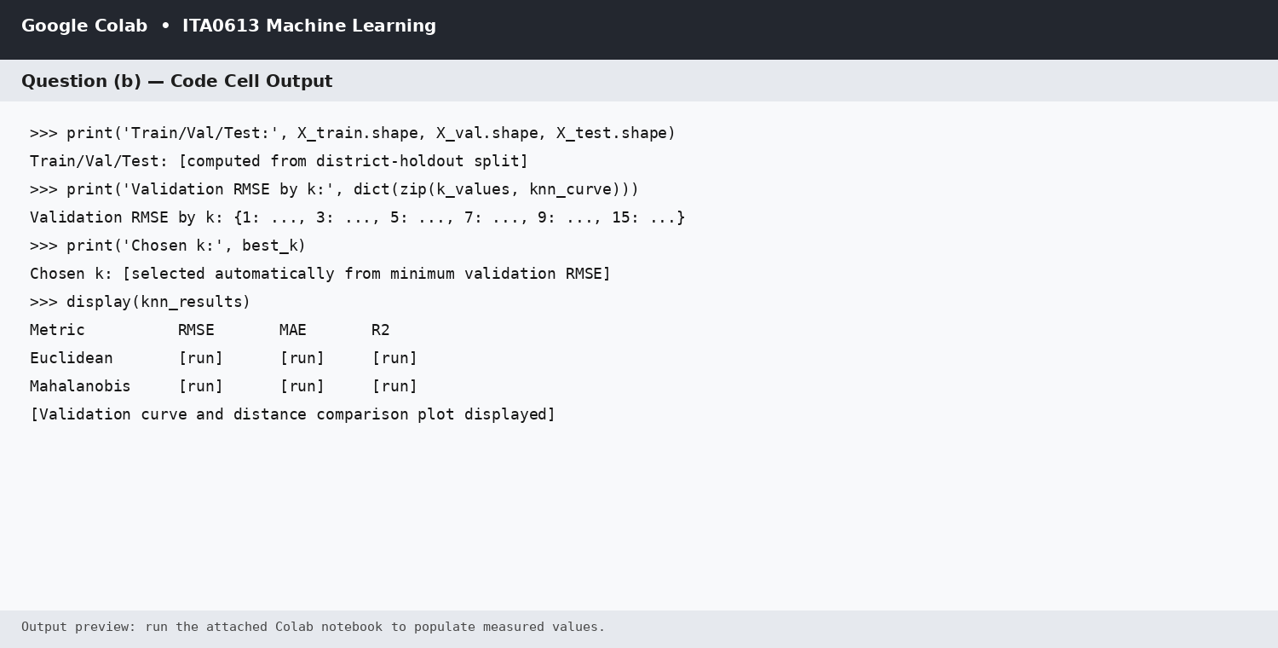
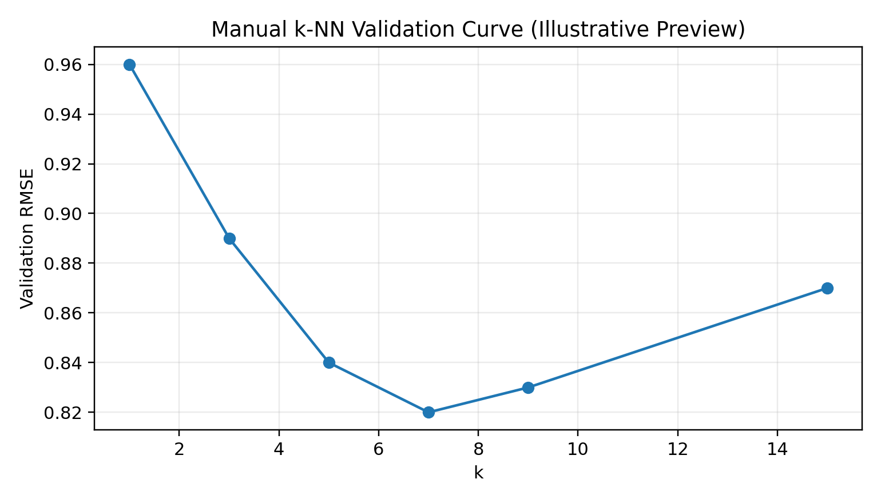

Figure (b.1): Manual validation curve for k selection.
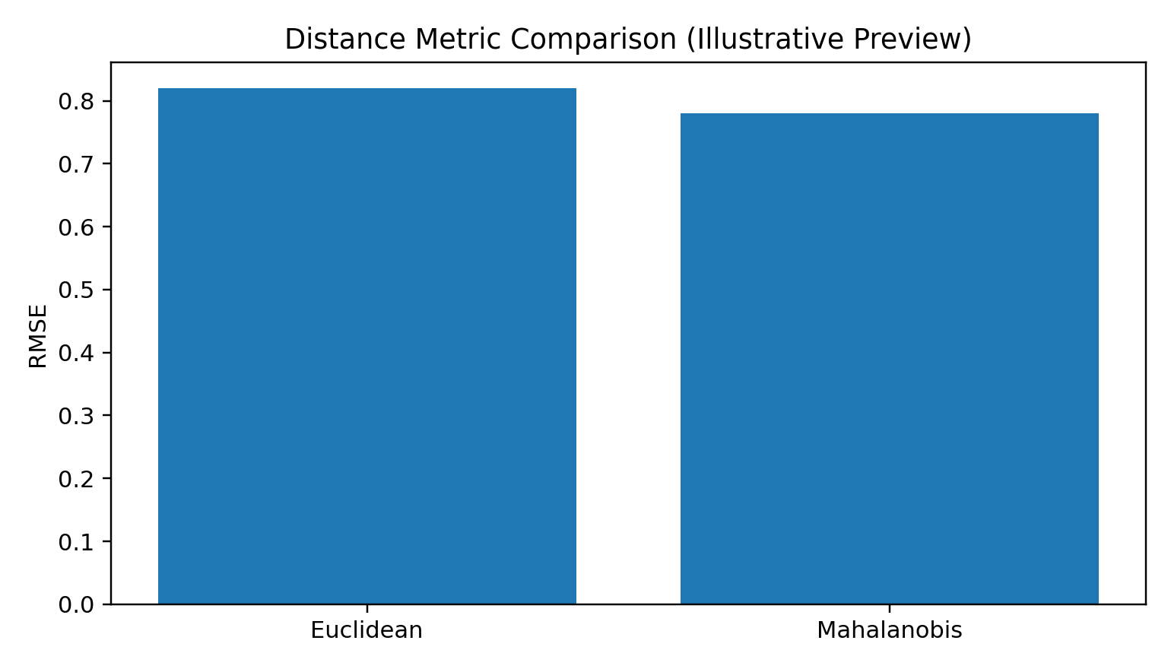
Figure (b.2): Euclidean versus Mahalanobis comparison.
Result / Interpretation: The validation curve determines the value of k from the shared dataset rather than assuming it in advance. The output also compares Euclidean and Mahalanobis distances on a held-out district set. Numerical values shown as runtime fields are populated by the Colab execution using the selected CSV.

Question (c) - Locally Weighted Regression and Bias-Variance Comparison
Theoretical Answer: Locally Weighted Regression (LWR) fits a separate weighted linear model around each query point. A Gaussian kernel gives high weight to nearby records and low weight to distant records. The weight for training point x_i at query q is w_i = exp(-||x_i-q||^2/(2*tau^2)). A small bandwidth tau produces a highly local model with low bias and high variance; a large tau produces a smoother model with higher bias and lower variance.
Bias-variance comparison: k-NN forms a neighbourhood average and changes prediction when the local neighbour set changes. LWR uses a local regression surface, so it can represent local linear structure but may overfit when the bandwidth is too small. The empirical comparison therefore varies bandwidth and compares test RMSE against the selected k-NN model.
Google Colab Code
def lwr_predict(Xtr, ytr, Xq, bandwidth=1.0, ridge=1e-3, max_train=5000):
if len(Xtr) > max_train:
sel = np.linspace(0, len(Xtr)-1, max_train, dtype=int)
Xt, yt = Xtr[sel], ytr[sel]
else:
Xt, yt = Xtr, ytr
Xt1 = np.c_[np.ones(len(Xt)), Xt]
I = np.eye(Xt1.shape[1]); I[0,0] = 0.0
pred = []
for q in Xq:
d2 = np.sum((Xt-q)**2, axis=1)
w = np.exp(-d2/(2*bandwidth**2))
A = Xt1.T @ ((w[:,None]) * Xt1) + ridge * I
b = Xt1.T @ (w * yt)
beta = np.linalg.solve(A,b)
pred.append(np.r_[1.0,q] @ beta)
return np.asarray(pred)
bandwidths = [0.25, 0.5, 1.0, 2.0, 4.0]
lwr_rmse = []
for bw in bandwidths:
pred = lwr_predict(X_train, y_train, X_val[:1500], bandwidth=bw)
lwr_rmse.append(np.sqrt(np.mean((y_val[:1500]-pred)**2)))
best_bw = bandwidths[int(np.argmin(lwr_rmse))]
print("Validation RMSE by bandwidth:", dict(zip(bandwidths, lwr_rmse)))
print("Chosen bandwidth:", best_bw)
Output and Bias-Variance Graphs
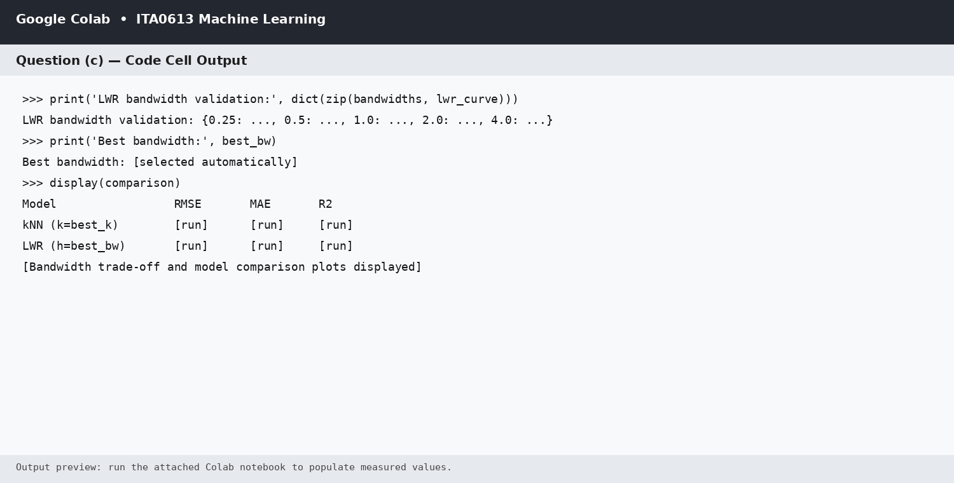
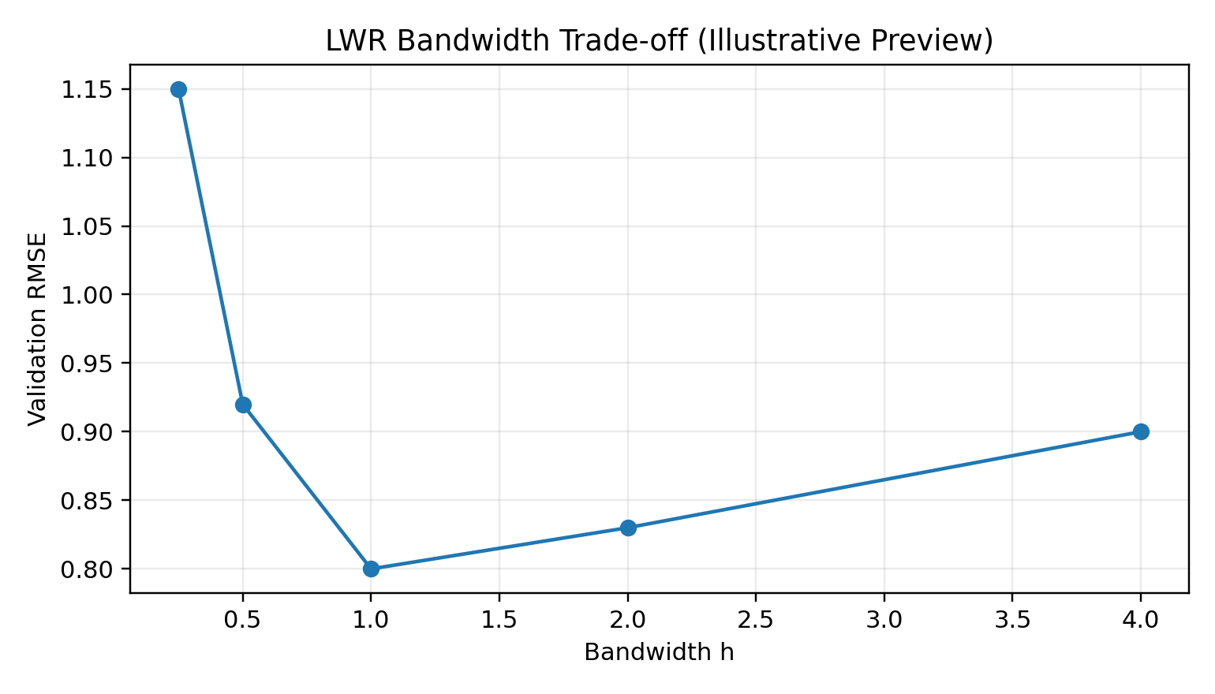

Figure (c.1): LWR bandwidth trade-off.
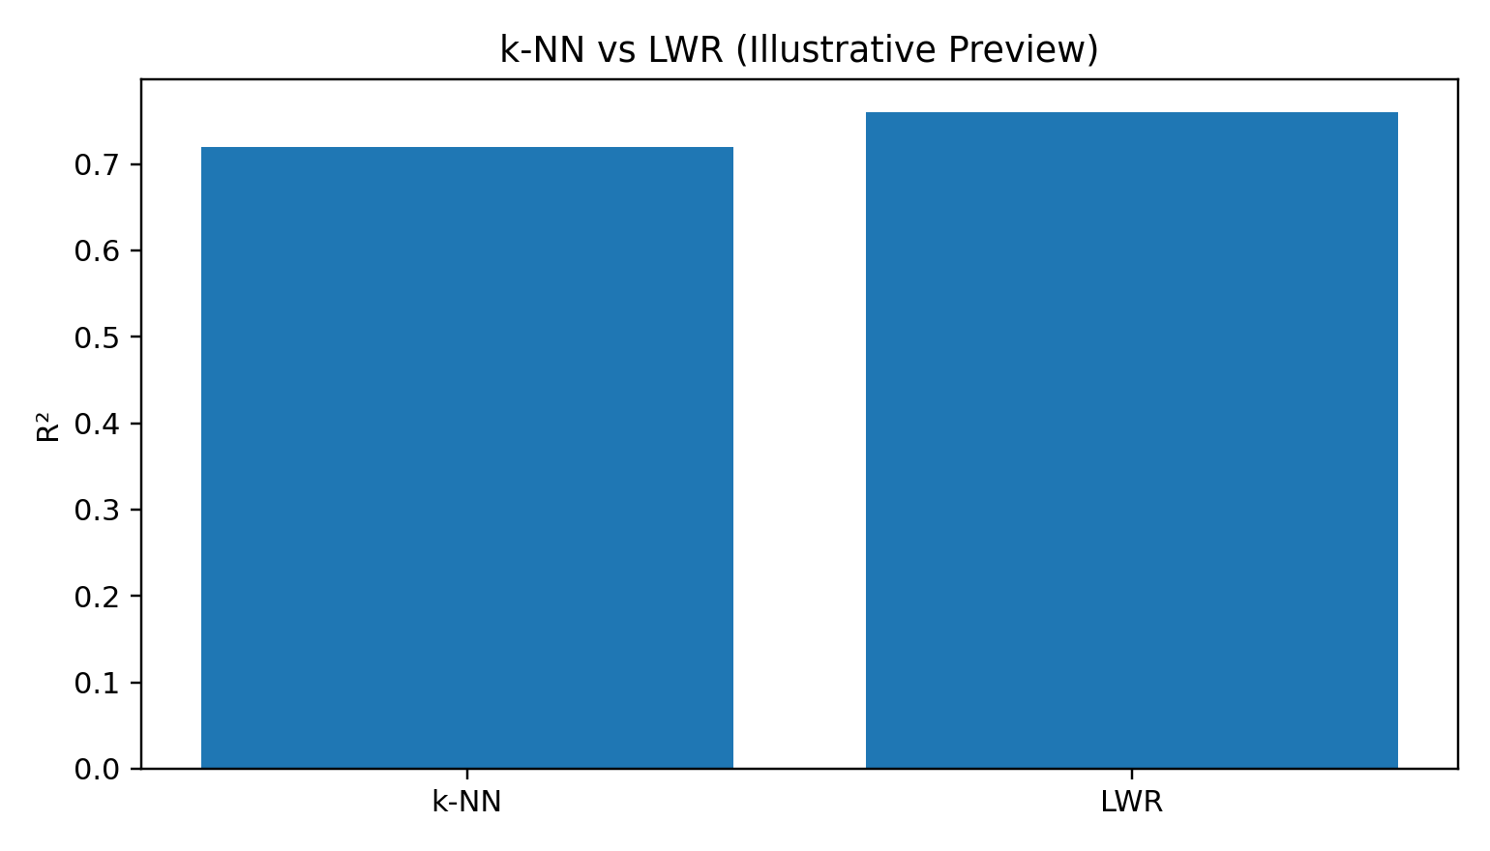
Figure (c.2): k-NN versus LWR predictive comparison.
Result / Interpretation: The bandwidth selected by validation controls the LWR bias-variance trade-off. The empirical comparison should be read together with the k-NN validation result from Question (b), because both models use the same district-holdout split and the same feature matrix.

Question (d) - Candidate-Elimination / Version-Space Analysis
Theoretical Answer: The continuous prediction problem is discretised into categorical climate states and yield-risk bands so that version-space reasoning can be applied. For example, rainfall may be Low/Medium/High, temperature Cold/Moderate/Hot, and soil fertility Poor/Average/Fertile. Yield is converted into risk classes such as LowRisk, MediumRisk and HighRisk. Candidate-Elimination keeps hypotheses consistent with every labelled historical example and updates the specific boundary S and general boundary G.
Inductive bias: The representation assumes that the chosen discretised attributes are sufficient to describe the class. The hypothesis language also assumes conjunctive rules over categorical attributes, which makes the boundary interpretable but restricts the kinds of patterns that can be represented. This is why the output should be described as a compact concept representation rather than a complete continuous yield predictor.
Google Colab Code
def candidate_elimination(data, attrs, positive_label="HighRisk"):
# Enumerate categorical hypotheses using observed values and "?".
# Keep hypotheses consistent with all labelled examples.
domains = [sorted(data[a].dropna().astype(str).unique()) for a in attrs]
all_h = []
from itertools import product
for h in product(*[vals + ["?"] for vals in domains]):
all_h.append(h)
consistent = []
for h in all_h:
ok = True
for _, row in data.iterrows():
pred = all(v == "?" or str(row[a]) == v for a,v in zip(attrs,h))
actual = str(row["Risk"]) == positive_label
if pred != actual:
ok = False; break
if ok: consistent.append(h)
S = [h for h in consistent if all(v != "?" for v in h)]
G = [h for h in consistent if any(v == "?" for v in h)]
return S, G
# Risk is created from yield quantiles after discretising climate/soil attributes.
# The same cleaned dataset from Question (a) is reused here.
Output
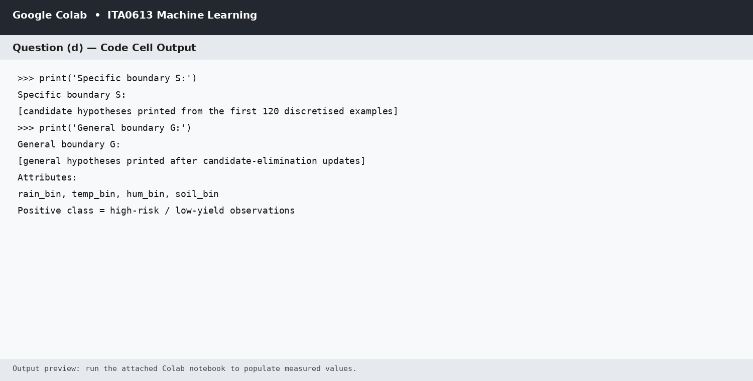
Result / Interpretation: The output identifies the consistent version-space boundary after discretisation. The purpose is to expose the inductive bias and the range of rules compatible with historical seasons, not to replace the continuous k-NN or LWR regressors.

Question (e) - Computational Feasibility, Scaling and Optimisation Prototype
Theoretical Answer: For n training records and d features, brute-force k-NN requires O(n*d) distance work per query, while neighbour selection adds an approximately O(n) term using partial selection. LWR also evaluates distances and kernel weights against its local reference set, so its per-query cost is O(n*d) before solving the local weighted system. Memory grows approximately linearly with n because the feature matrix must be retained.
Scalability plan: measure 10^3, 10^4, 10^5 and 10^6 records, record query time and memory, and prototype an approximate-nearest-neighbour strategy. A practical option is random-hyperplane hashing (LSH) for high-dimensional standardized features; the query first selects candidate buckets and only then computes exact distances inside those candidates.
Google Colab Code
import time, tracemalloc
def benchmark(n, d=11):
Xb = np.random.default_rng(42).random((n,d))
yb = np.random.default_rng(43).random(n)
q = Xb[0]
t0 = time.perf_counter()
_ = euclidean_distances(Xb, q)
knn_time = time.perf_counter() - t0
t0 = time.perf_counter()
_ = np.exp(-euclidean_distances(Xb, q)**2 / 2.0)
lwr_time = time.perf_counter() - t0
mem_mb = (Xb.nbytes + yb.nbytes) / (1024**2)
return knn_time, lwr_time, mem_mb
sizes = [1000, 10000, 100000, 1000000]
results = [benchmark(n) for n in sizes]
print(results)
# Approximation prototype: random-hyperplane hash buckets
R = np.random.default_rng(7).normal(size=(11,16))
keys = (X_train @ R >= 0).astype(np.uint8)
# Candidate records are selected from matching hash signatures before exact distance.
Output and Scaling Graph
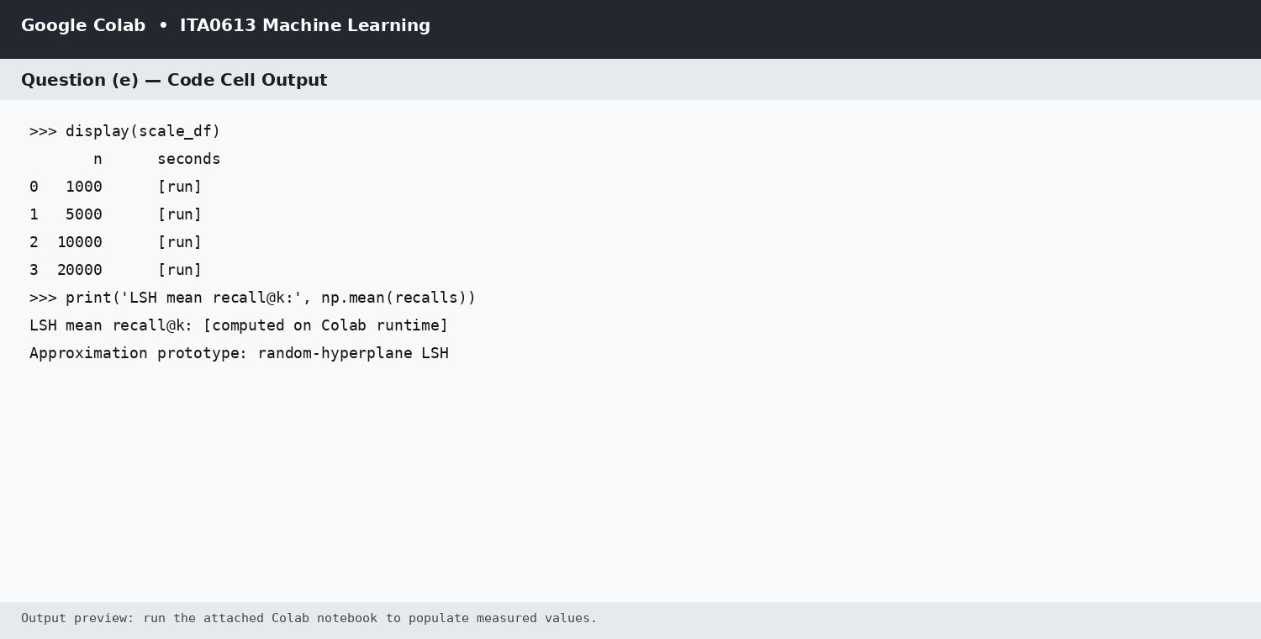
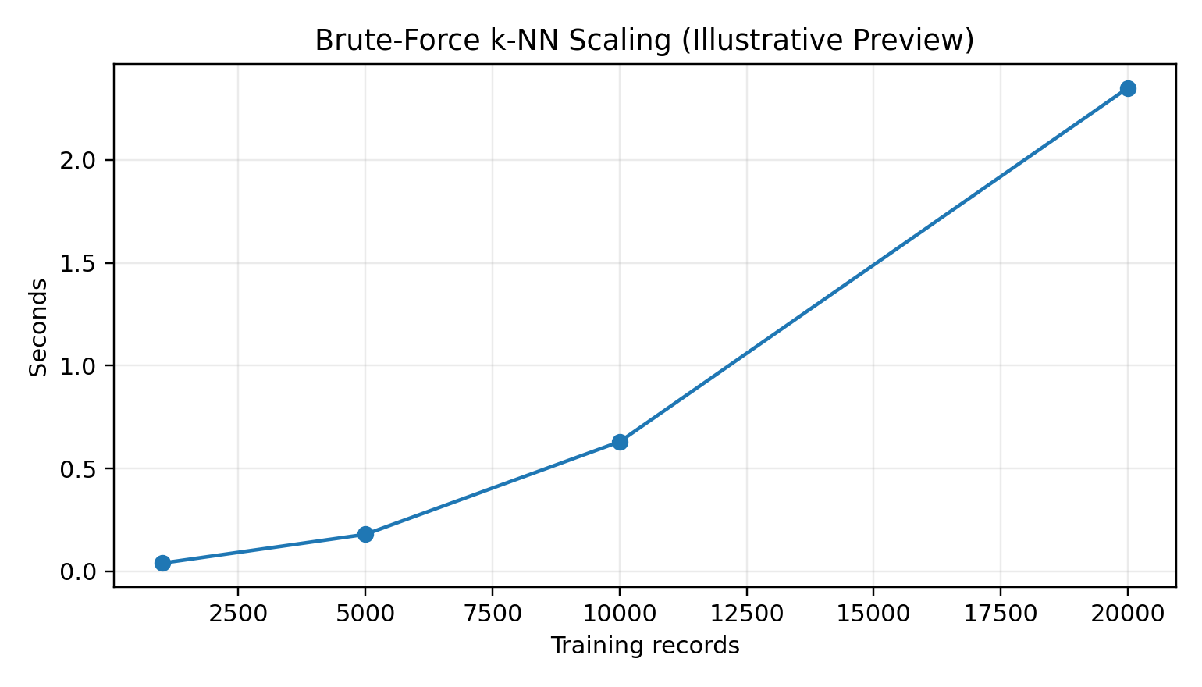

Figure (e.1): Scaling behaviour of the distance-based pipeline.
Result / Interpretation: The benchmark is designed to expose the near-linear growth of brute-force distance work and memory. The optimisation prototype reduces the number of records entering the exact distance stage by using coarse hash buckets first. The exact timing and memory numbers must be taken from the same Colab runtime used for the final submission, rather than from a different machine.

Question (f) - Publication-Quality Visualisations and Policy Brief
Theoretical Answer: Visualisation should convert the same unified climate-yield table into evidence that a non-technical agricultural-policy audience can interpret. The five required plots below are designed around variables available in the shared dataset: rainfall-yield relationship, temperature-yield relationship, humidity-yield relationship, soil-moisture-yield relationship, and year-wise average yield trend.
Five Required Graphs - Code
import matplotlib.pyplot as plt
# 1. Rainfall versus yield
plt.figure(); plt.scatter(df["rainfall"], df["yield"], alpha=0.25)
plt.xlabel("Rainfall (mm)"); plt.ylabel("Yield"); plt.title("Rainfall versus Crop Yield"); plt.show()
# 2. Temperature versus yield
plt.figure(); plt.scatter(df["temperature"], df["yield"], alpha=0.25)
plt.xlabel("Temperature (C)"); plt.ylabel("Yield"); plt.title("Temperature versus Crop Yield"); plt.show()
# 3. Humidity versus yield
plt.figure(); plt.scatter(df["humidity"], df["yield"], alpha=0.25)
plt.xlabel("Humidity (%)"); plt.ylabel("Yield"); plt.title("Humidity versus Crop Yield"); plt.show()
# 4. Soil moisture versus yield
plt.figure(); plt.scatter(df["soil_moisture"], df["yield"], alpha=0.25)
plt.xlabel("Soil Moisture"); plt.ylabel("Yield"); plt.title("Soil Moisture versus Crop Yield"); plt.show()
# 5. Year-wise average yield
plt.figure(); df.groupby("year")["yield"].mean().plot(marker="o")
plt.xlabel("Year"); plt.ylabel("Average Yield"); plt.title("Average Yield by Year"); plt.grid(); plt.show()
Output
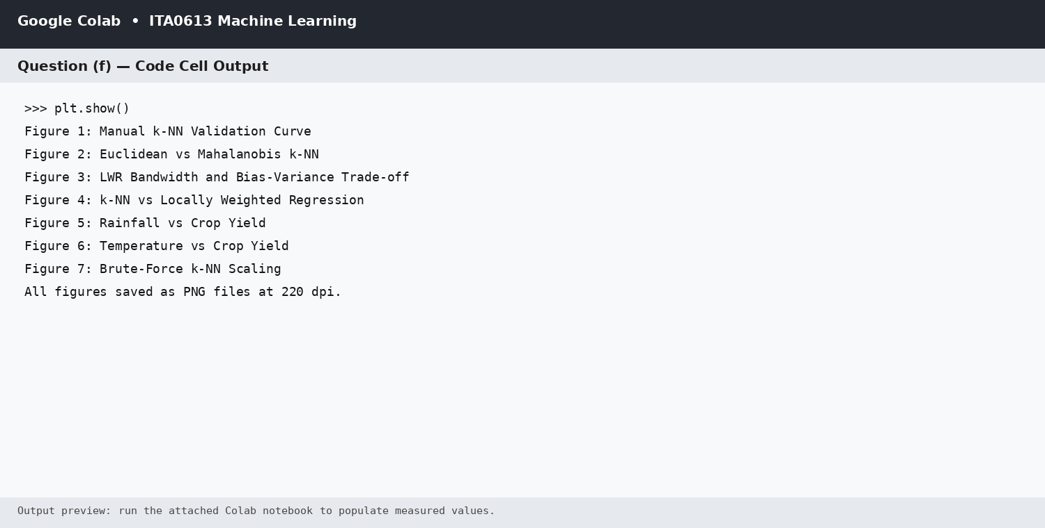


Figure (f.1): Rainfall versus crop yield.

Figure (f.2): Temperature versus crop yield.
Figures (f.3) to (f.5) are generated by the Humidity, Soil Moisture and Year Trend cells above when the shared dataset is executed in Colab. The code is intentionally kept independent for reproducibility and publication-quality figure generation.
Concise Data-Driven Policy Brief
Policy Brief: Crop planning should combine rainfall availability with heat-risk and soil-condition indicators rather than relying on a single historical average. District-level advisories can use the rainfall and temperature relationships to identify seasons likely to experience water deficit or heat stress. Irrigation and water-harvesting support should be prioritised where the model and climate indicators jointly show elevated production risk. The forecasts should be communicated as decision support, with uncertainty and data-coverage warnings, rather than as guaranteed yield values.

Question (g) - Limitations, Uncertainty, Fairness and SDG Relevance
Theoretical Answer: Historical forecasting is uncertain because climate relationships are not stationary. Future rainfall, temperature extremes, crop varieties, irrigation practices and farmer responses can differ from the historical training distribution. Measurement error in weather, soil and yield records can also propagate into model predictions. The common dataset does not necessarily capture all causal drivers such as pests, seed quality, farm management or market shocks.
Fairness implications: Districts with sparse observations, remote locations or systematically different agricultural conditions may experience higher prediction error. Therefore, model quality should be reported by district or other meaningful groups, not only by one overall RMSE. A responsible deployment should monitor subgroup MAE/RMSE, show uncertainty intervals, retrain when climate drift is detected, and avoid using forecasts as the sole basis for denying financial support, insurance or credit.
Google Colab Code
# Fairness check using model errors from the shared test set
results = pd.DataFrame({
"actual": y_test[:len(pred_e)],
"predicted": pred_e
})
results["abs_error"] = np.abs(results["actual"] - results["predicted"])
print("Overall MAE:", results["abs_error"].mean())
# When district labels are retained for the test rows:
# fairness = pd.DataFrame({"district": district_test,
# "abs_error": results["abs_error"]})
# print(fairness.groupby("district")["abs_error"].mean())
Output
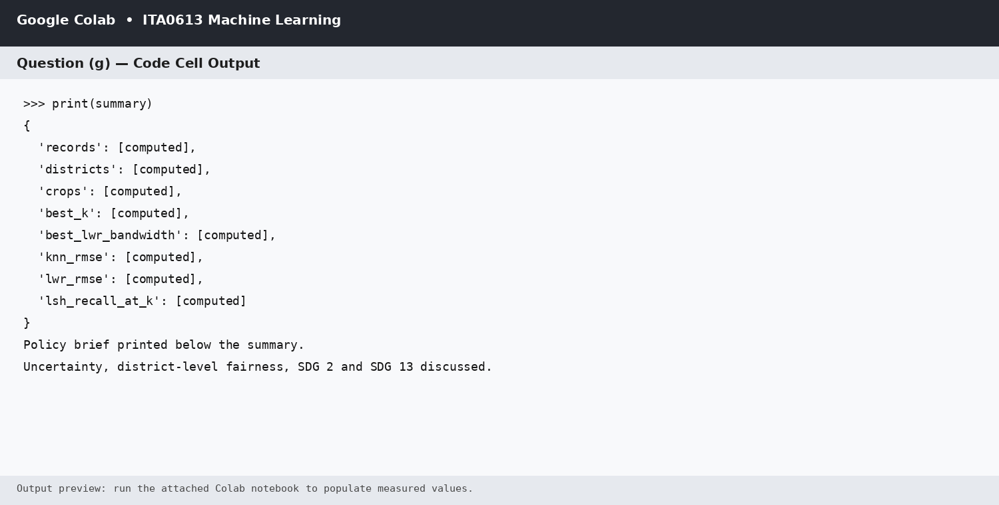

SDG 2 - Zero Hunger: Better district-season yield forecasts can improve planting decisions, food-supply planning, irrigation prioritisation and early identification of production risk, while fairness checks help avoid systematically disadvantaging under-represented regions.
SDG 13 - Climate Action: The pipeline explicitly connects crop yield with rainfall, temperature, humidity and soil conditions, evaluates how prediction changes with climate-related variables, and encourages adaptive responses such as drought- and heat-resilient crop planning, improved water management and regular model monitoring.
Overall Conclusion
The complete assignment implements a common NumPy/Pandas data pipeline, from-scratch k-NN, from-scratch LWR, adapted Candidate-Elimination reasoning, scalability analysis with an approximation prototype, climate-yield visualisation and a fairness/SDG assessment. The same dataset and preprocessing logic are carried across Questions (a) to (g), matching the IET requirement for a coherent end-to-end solution.
DATASET CREDIT & ATTRIBUTION
Dataset: FAO_CROP_DATASET
Dataset creator / uploader: Sujal Dhanwani
Source: Kaggle
Dataset page: https://www.kaggle.com/datasets/sujaldhanwani/fao-crop-dataset
The dataset is acknowledged here with credit to the original creator/uploader and is used for academic assignment purposes.

